Deployment
Overview
The following document helps developer to deploy the application in IIS.
Revision
Revision | Date | Author | Description
1 | 18-03-2019 | Anu Tejaswy | Regulatory portal deployment
2 | 31-07-2019 | Kapil Khubchandani | Added Important things to keep in mind.

Please follow the below steps :

step 1 : open cmd in C:\Users\atejaswy\source\repos\RegulatoryPortal

Step 2 : run the following command
dotnet publish --framework netcoreapp2.1 --output "c:\temp\AlbumViewerWeb" --configuration Release

The folder path can be anything (c:\temp\AlbumViewerWeb) to save the published files.

step 3: After the publish is done to the above path in the output command

Step4: open IIS and add an application pool.
Add an application pool as below:
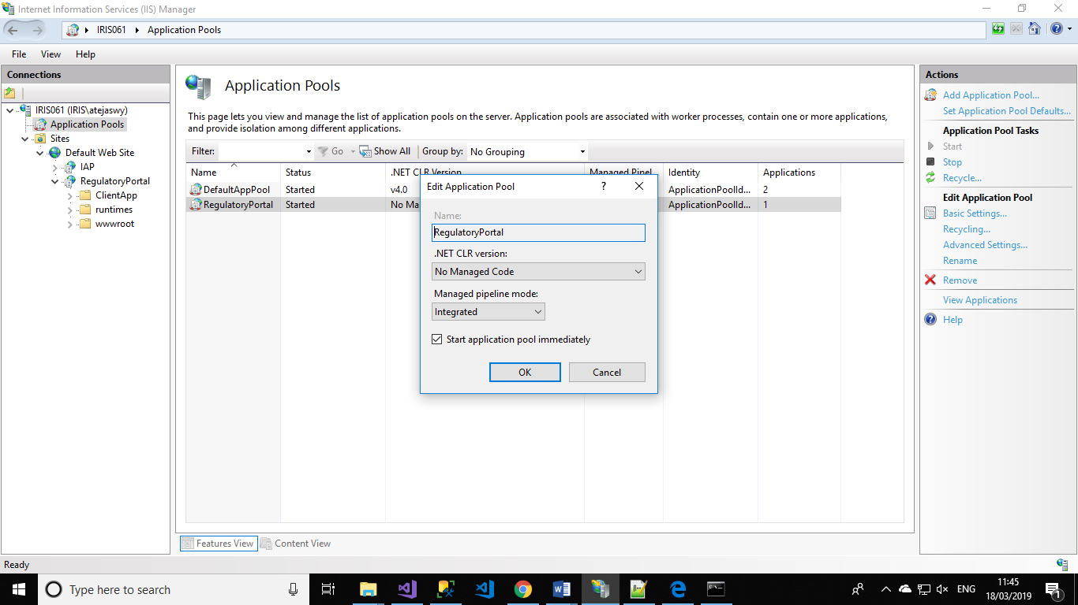

Step5:
Add an site as below and give the same application pool created and provide the physical path.
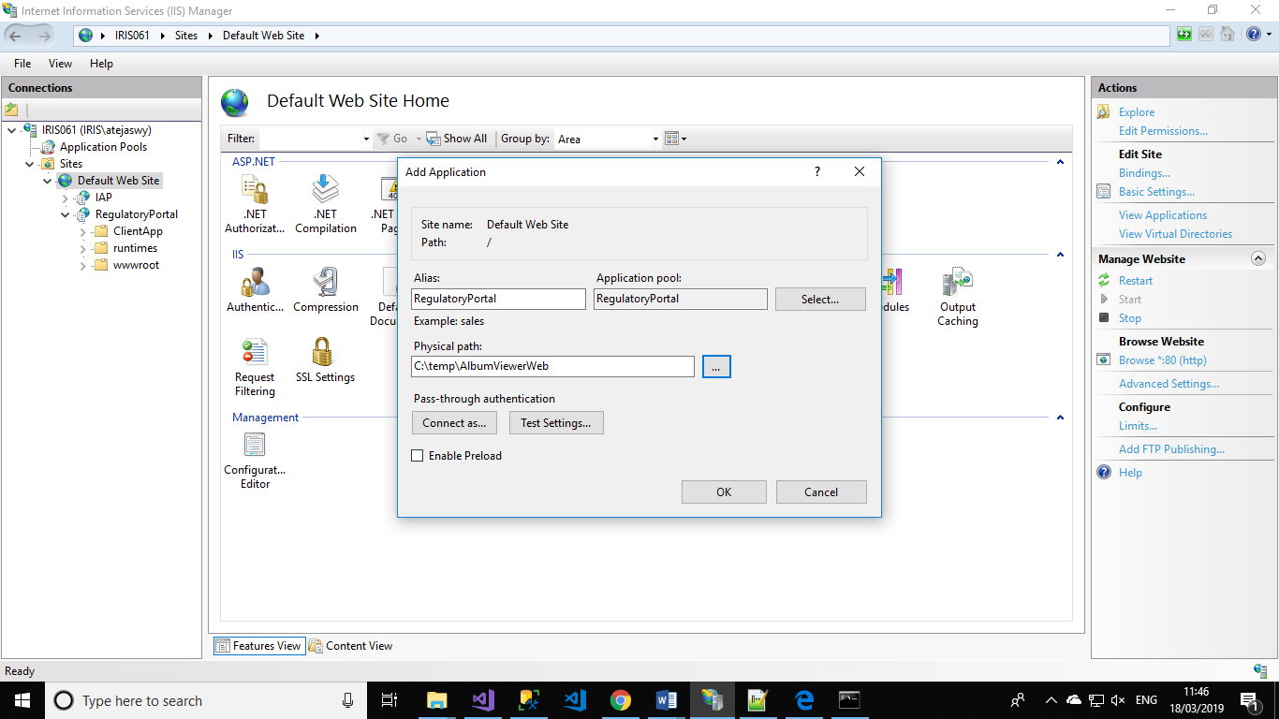

Step6:
change the base href url to as you want in the index.html file in publish folder
Eg : “/RegulatoryPortal/” as value for base href url in the index.html page

Step7:
Browse the application
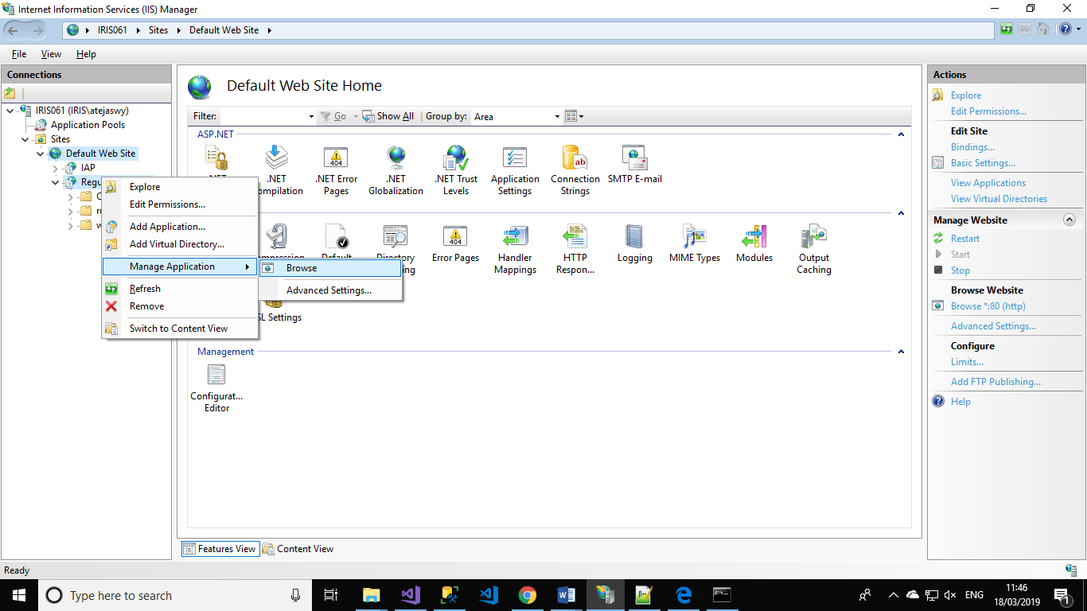

You will be able to see the application
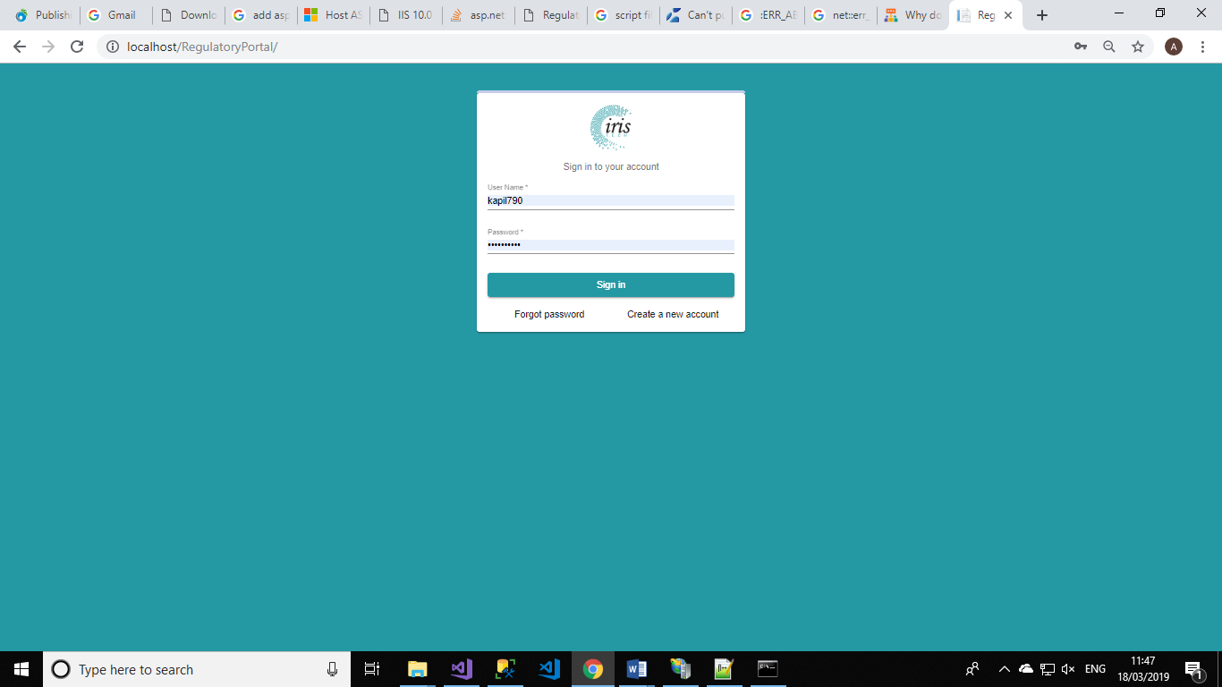

Important things to keep in mind.
- In web.config in the below element, “processPath” must point to dotnet.exe
<aspNetCore processPath="C:\Program Files\dotnet\dotnet.exe" arguments=".\RegulatoryPortal.dll" stdoutLogEnabled="true" stdoutLogFile=".\logs\stdout" />
- To know where is dotnet.exe , run following command in cmd
where dotnet

- You should install dotnetcore runtime and hosting bundle version netcoreapp2.1
<TargetFramework>netcoreapp2.1</TargetFramework>
In a new machine.

